S. DARSHAN 24BCE5311

COMPUTER NETWORKS LAB BCE308P
Exp 6. Checksum Calculation
06.02.2026

AIM
To capture live network traffic and validate packet checksums using three different methods: Wireshark’s built-in checksum validation, manual checksum calculation, and programmatic checksum verification using the Scapy library for TCP packets.

PROCEDURE
- Wireshark was installed and a suitable network interface was selected to capture live network traffic.
- Live packets were captured while generating network activity and the captured traffic was saved as a .pcapng file.
- Method-1: A TCP packet was selected in Wireshark and the checksum validation feature was enabled. The checksum field was observed and verified using Wireshark’s automatically calculated checksum.
- Method-2: The same TCP packet was used for manual checksum verification. The IPv6 pseudo-header and TCP header fields were extracted from Wireshark. The TCP checksum was calculated by summing all 16-bit words using one’s complement arithmetic and taking the one’s complement of the final sum. The calculated checksum was compared with the checksum displayed by Wireshark.
- Method-3: The captured pcap file was analyzed using a Python program written with the Scapy library. The stored TCP checksum was extracted, recalculated programmatically, and compared to verify packet integrity.
- The results from all three methods were recorded and validated.
OBSERVATIONS
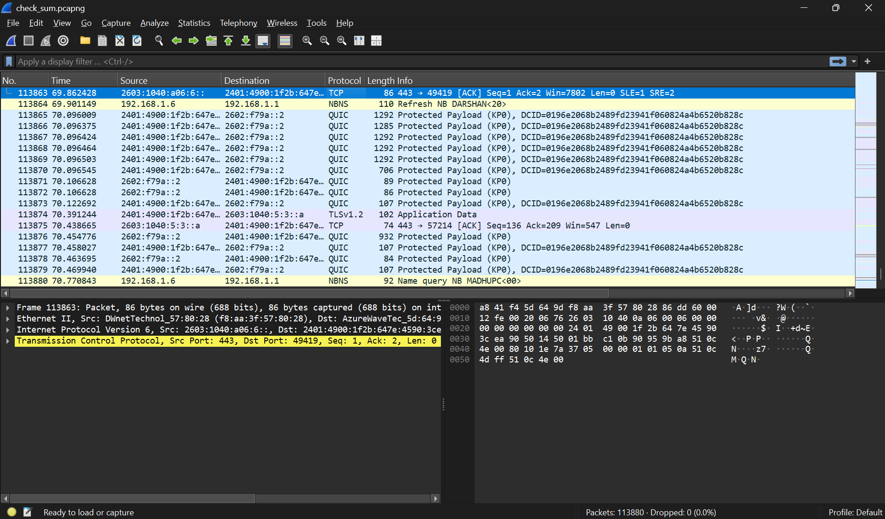

METHOD - 1
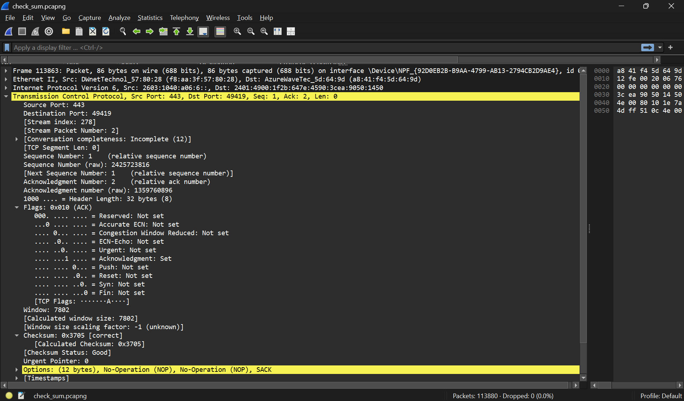
METHOD 2
Hex Steam
a841f45d649df8aa3f57802886dd600000000014063b24014900005000090000000000000280240149001f2b647e45903cea905014500035c38c42d9891e6569ae8050100e6c76250000
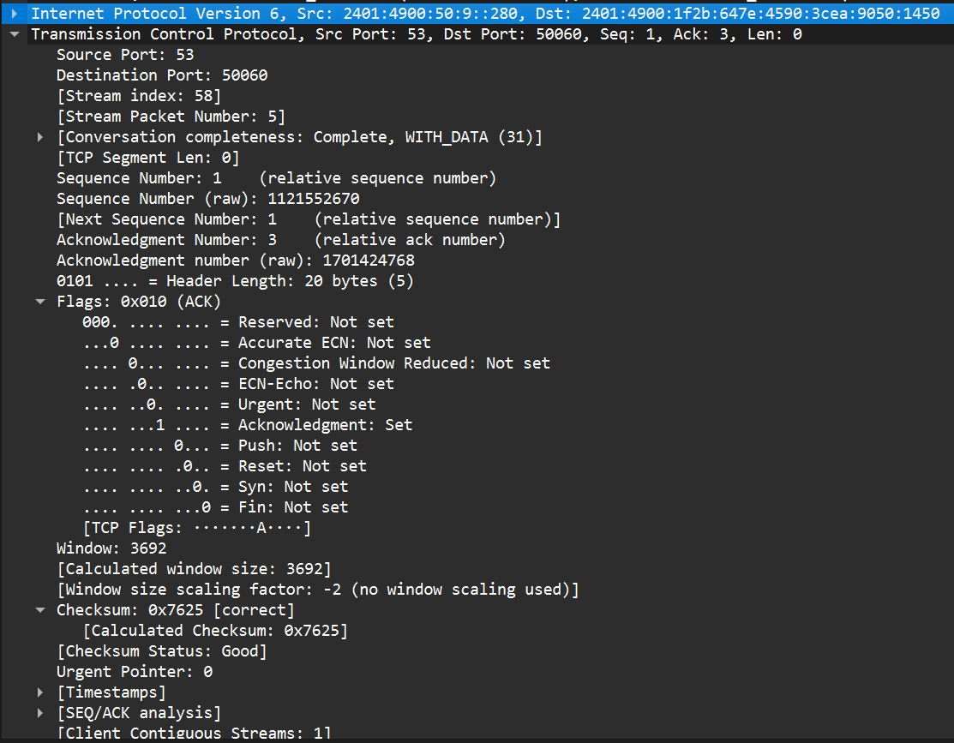

Packet Chosen
- Network layer: IPv6
- Transport layer: TCP
- Source IP: 2401:4900:50:9::280
- Destination IP: 2401:4900:1f2b:647e: 4590:3cea:9050:1450
- Source Port: 53
- Destination Port: 50060
- TCP Header Length: 20 bytes
- TCP Payload Length: 0
- TCP Checksum (Wireshark): 0x7625 ✔
Calculation
- Source IPv6 Address = 2401:4900:0050: 0009:0000:0000: 0000:0280
- Destination IPv6 Address = 2401:4900:1f2b:647e: 4590:3cea: 9050:1450
- Upper-Layer Packet Length = 0014
- Next Header (TCP) = 0006
- IPv6 Pseudo-Header (16-bit words):
2401 + 4900 + 0050 + 0009 + 0000 + 0000 + 0000 + 0280 + 2401 + 4900 + 1f2b + 647e + 4590 + 3cea + 9050 + 1450 + 0000 + 0014 + 0000 + 0006
= 0x8B19
- TCP Header (checksum field set to 0000):
0035 + C3FC + 42D7 + FDEE + 6564 + B35C + 5010 + 0E6C + 0000 + 0000
= 0xF6C1
- Total Sum = 0x8B19 + 0xF6C1 = 0x181DA
- Wrap Carry: 0x81DA + 0x0001 = 0x81DB
- One’s Complement of Final Sum:
~0x81DB = 0x7625
- Calculated TCP Checksum = 0x7625
Wireshark TCP Checksum = 0x7625

METHOD 3
CODE
from scapy.all import *
packets = rdpcap("C:\\Darshan\\College\\CN Lab\\check_sum.pcapng")
for pkt in packets:
if IP in pkt:
ip = pkt[IP]
old_ip_chksum = ip.chksum
del ip.chksum
new_ip_chksum = IP(bytes(ip)).chksum
print("IP Checksum:")
print("Stored:", old_ip_chksum, "Calculated:", new_ip_chksum)
if TCP in pkt:
tcp = pkt[TCP]
old_tcp_chksum = tcp.chksum
del tcp.chksum
new_tcp_chksum = TCP(bytes(tcp)).chksum
print("TCP Checksum:")
print("Stored:", old_tcp_chksum, "Calculated:", new_tcp_chksum)
if UDP in pkt:
udp = pkt[UDP]
old_udp_chksum = udp.chksum
del udp.chksum
new_udp_chksum = UDP(bytes(udp)).chksum
print("UDP Checksum:")
print("Stored:", old_udp_chksum, "Calculated:", new_udp_chksum)
if ICMP in pkt:
icmp = pkt[ICMP]
old_icmp_chksum = icmp.chksum
del icmp.chksum
new_icmp_chksum = ICMP(bytes(icmp)).chksum
print("ICMP Checksum:")
print("Stored:", old_icmp_chksum, "Calculated:", new_icmp_chksum)
print("-" * 40)

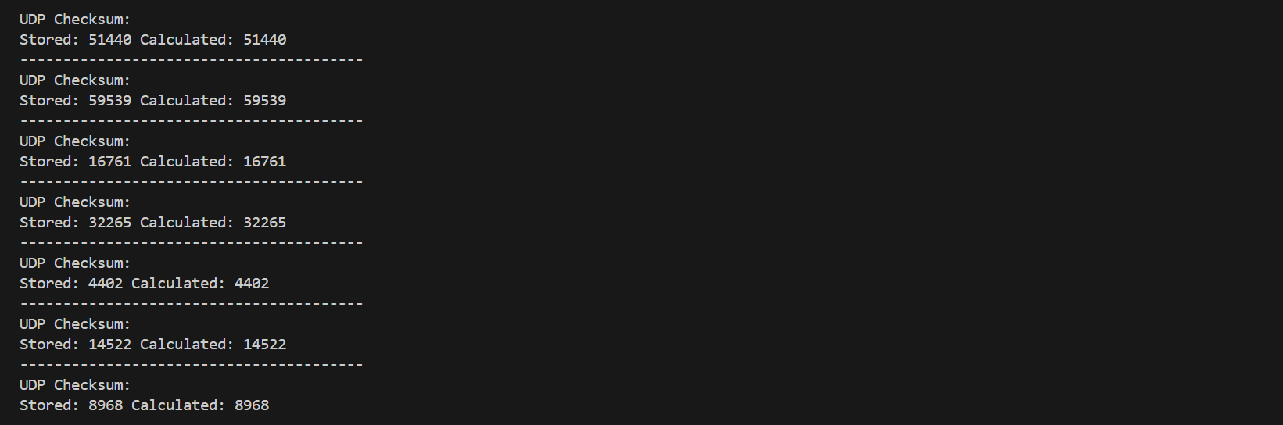

CONCLUSION
The experiment successfully demonstrated checksum validation of TCP packets using three different approaches. Wireshark’s built-in validation confirmed the correctness of the checksum, manual calculation verified the checksum using standard one’s complement arithmetic, and Scapy provided automated checksum verification through programming. All three methods produced matching checksum values, thereby confirming the integrity of the captured TCP packet.

